

**PROJECT PROPOSAL**

**(TOUCH SENSOR ALARM)**

**Section: B**

**Engineering Work Shop**

**Submitted By**

**Zia ul Islam (R.No:33)**

**Abdul Raheem (R: No: 27)**

**Ashfaq Ahmad (R.No:31)**

**Shah Husain (R.No:16)**

**Submitted to:**

**Engr Muhammad Noman**

**8 Jan, 2020**

**Department of Computer System Engineering**

**University of Engineering and Technology Peshawar**

**How to make a touch sensor alarm**

**INTRODUCTION:**

A touch sensor is a type of equipment that captures and records physical touch or embrace on a device and/or object. It enables a device or object to detect touch, typically by a human user or operator. A touch sensor may also be called a touch detector. This little and flexible circuit consist of a touch sensor and NE-555 IC with small buzzer as the output loud. Two touch sensor strips of metal are mounted side by side and connected to input of the circuit.

**Apparatus:**

* Buzzer (3-27v)
* Breadboard
* LED
* Resister (330ohm)
* 555 IC
* Connecting wires
* Battery (5-12v)

**Buzzer:**

A **buzzer** or beeper is an audio signaling device, which may be mechanical, electromechanical, or piezoelectric (piezo for short). Typical uses of **buzzers** and beepers include alarm devices, timers, and confirmation of user input such as a mouse click or keystroke

**Working principle:**

The **working** of a **touch sensor** is similar to that of a simple switch. When there is contact with the surface of the **touch sensor**, the circuit is closed inside the **sensor** and there is a flow of current. When the contact is released, the circuit is opened and no current flows.

**Procedure:**

* Connect the 555 ic on breadboard.
* Connect the one terminal of buzzer to the pin no 3 of ic and other terminal to pin no1.
* Now connect the –ive terminal of LED to pin no3 of ic and other terminal of LED to ist terminal of resister having value 330 ohm, while the second terminal of resister to pin no 8 ogf ic.
* Connect the +ive terminal of power supply to pin no 8 and –ive terminal to pin no 1.
* Now connect two touch plates at pin 1 and 2.
* Connect two other touch plates at pin no 8 and 6.
* The circuit is complete.

**Circuit diagram:**

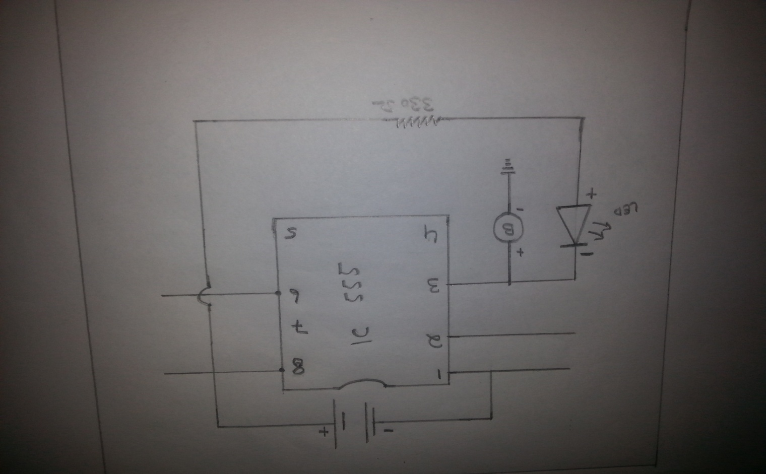

**Working:**

The main part of this circuit is 55 IC timers which is set as a monostable multiviberator. The metallic loop (here we used as a pin) to pin 2 of 555 and it is active low when the pin 2 is grounded the latch output will be set to pin 1 and when pin 4 is grounded the latch is reset, the output of the latch is given to buzzer. Trigger determine the output of NE-555 : this trigger pin set the flip flop inside the 555 timer. When this pin is high the output will be high and vice versa. As said earlier this pin is very sensitive it will pull the 555 output high by touch LED will not turn on as the trigger not given. The trigger pin in timer is high impedance one and is very sensitive . this pin can merely pulled high by human body potential . so on touch the trigger pin forces the internal flip flop to set mode and so the output goes high. Touch the sensor plates of alarm with your finger and it start beeping.

Touching it again and it starts beeping!!

Application:

* It can be used in touch-based blinking lights.
* It can be used to detect the electrostatic build up in a room.
* Touch switches for doorbells.
* It can be used to make touch-based buzzers.

**END**